Top of Form

Search

Submit your search query

Bottom of Form

[Forum](https://forum.freecodecamp.org/) [Donate](https://www.freecodecamp.org/donate/)

**[Learn to code — free 3,000-hour curriculum](https://www.freecodecamp.org/" \t "_blank)**

SEPTEMBER 14, 2021/[#PYTHON](https://www.freecodecamp.org/news/tag/python/)

**Python f-String Tutorial – String Formatting in Python Explained with Code Examples**

[**Bala Priya C**](https://www.freecodecamp.org/news/author/bala-priya/)

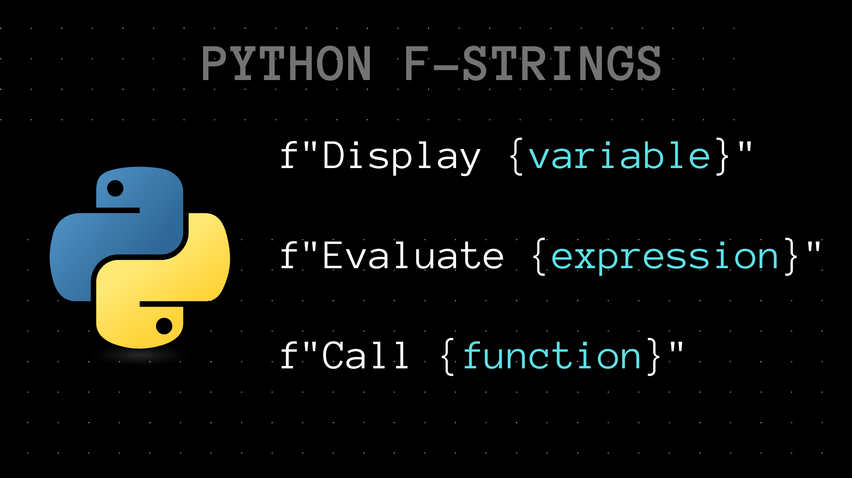

When you're formatting strings in Python, you're probably used to using the format() method.

But in Python 3.6 and later, you can use *f-Strings*instead. f-Strings, also called *formatted string literals,* have a more succinct syntax and can be super helpful in string formatting.

In this tutorial, you'll learn about f-strings in Python, and a few different ways you can use them to format strings.

**What are f-Strings in Python?**

Strings in Python are usually enclosed within double quotes ("" ) or single quotes (''). To create f-strings, you only need to add an f  or an F before the opening quotes of your string.

For example, "This" is a string whereas f"This" is an f-String.

**How to Print Variables using Python f-Strings**

When using f-Strings to display variables, you only need to specify the names of the variables inside a set of curly braces {}. And at runtime, all variable names will be replaced with their respective values.

If you have multiple variables in the string, you need to enclose each of the variable names inside a set of curly braces.

The syntax is shown below:

f"This is an f-string {var\_name} and {var\_name}."

▶ Here's an example.

You have two variables, language and school, enclosed in curly braces inside the f-String.

language = "Python"

school = "freeCodeCamp"

print(f"I'm learning {language} from {school}.")

Let's take a look at the output:

#Output

I'm learning Python from freeCodeCamp.

Notice how the variables language and school have been replaced with Python and freeCodeCamp, respectively.

**How to Evaluate Expressions with Python f-Strings**

As f-Strings are evaluated at runtime, you might as well evaluate valid Python expressions on the fly.

▶ In the example below, num1 and num2 are two variables. To calculate their product, you may insert the expression num1 \* num2 inside a set of curly braces.

num1 = 83

num2 = 9

print(f"The product of {num1} and {num2} is {num1 \* num2}.")

Notice how num1 \* num2 is replaced by the product of num1 and num2 in the output.

#Output

The product of 83 and 9 is 747.

I hope you're now able to see the pattern.

In any f-String, {var\_name}, {expression} serve as placeholders for variables and expressions, and are replaced with the corresponding values at runtime.

Head over to the next section to learn more about f-Strings.

**How to Use Conditionals in Python f-Strings**

Let's start by reviewing Python's if..else statements. The general syntax is shown below:

if condition:

# do this if condition is True <true\_block>

else:

# do this if condition is False <false\_block>

Here, condition is the expression whose truth value is checked.

* If the condition evaluates to True, the statements in the if block (<true\_block>) are executed.
* If the condition evaluates to False, the statements in the else block (<false\_block>) are executed.

There's a more succinct one-line equivalent to the above if..else blocks. The syntax is given below:

<true\_block> if <condition> else <false\_block>

In the above syntax,<true block> is what's done when the condition is True, and <false\_block> is the statement to be executed when the condition is False.

This syntax may seem a bit different if  you haven't seen it before. If it makes things any simpler, you may read it as, "*Do this* if condition is True; else, *do this*".

This is often called the *ternary* operator in Python as it takes 3 operands in some sense – the *true block*, the *condition* under test, and the *false block*.

▶ Let's take a simple example using the ternary operator.

Given a number num, you'd like to check if it's even. You know that a number is even if it's evenly divisible by 2. Let's use this to write our expression, as shown below:

num = 87;

print(f"Is num even? {True if num%2==0 else False}")

In the above code snippet,

* num%2==0 is the condition.
* If the condition is True, you just return True indicating that num is indeed even, and False otherwise.

#Output

Is num even? False

In the above example, num is 87, which is odd. Hence the conditional statement in the f-String is replaced with False.

**How to Call Methods with Python f-Strings**

So far, you've only seen how to print values of variables, evaluate expressions, and use conditionals inside f-Strings. And it's time to level up.

▶ Let's take the following example:

author = "jane smith"

print(f"This is a book by {author}.")

The above code prints out This is a book by jane smith.

Wouldn't it be better if it prints out This is a book by Jane Smith. instead? Yes, and in Python, string methods return modified strings with the requisite changes.

The title() method in Python returns a new string that's formatted in the title case - the way names are usually formatted (First\_name Last\_name).

To print out the author's name formatted in title case, you can do the following:

* use the title() method on the string author,
* store the returned string in another variable, and
* print it using an f-String, as shown below:

author = "jane smith"

a\_name = author.title()

print(f"This is a book by {a\_name}.")

#Output

This is a book by Jane Smith.

However, you can do this in just one step with f-Strings. You only need to call the title() method on the string author inside the curly braces within the f-String.

author = "jane smith"

print(f"This is a book by {author.title()}.")

When the f-String is parsed at runtime,

* the title() method is called on the string author, and
* the returned string that's formatted in title case is printed out.

You can verify that in the output shown below.

#Output

This is a book by Jane Smith.

You can place method calls on any valid Python object inside the curly braces, and they'll work just fine.

**How to Call Functions Inside Python f-Strings**

In addition to calling methods on Python objects, you can also call functions inside f-Strings. And it works very similarly to what you've seen before.

Just the way variable names are replaced by values, and expressions are replaced with the result of evaluation, function calls are replaced with the return value from the function.

▶ Let's take the function choice() shown below:

def choice(c):

if c%2 ==0:

return "Learn Python!"

else:

return "Learn JavaScript!"

The above function returns "Learn Python!" if it's called with an even number as the argument. And it returns "Learn JavaScript!" when the argument in the function call is an odd number.

▶ In the example shown below, you have an f-String that has a call to the choice function inside the curly braces.

print(f"Hello Python, tell me what I should learn. {choice(3)}")

As the argument was an odd number (3), Python suggests that you learn JavaScript, as indicated below:

#Output

Hello Python, tell me what I should learn. Learn JavaScript!

If you call the function choice() with an even number, you see that Python tells you to learn Python instead. 🙂

print(f"Hello Python, tell me what I should learn. {choice(10)}")

#Output

Hello Python, tell me what I should learn. Learn Python!

And that ends our tutorial on a happy note!

**Conclusion**

In this tutorial, you've learned how you can use f-Strings to:

* print values of variables,
* evaluate expressions,
* call methods on other Python objects, and
* make calls to Python functions.

**Related Posts**

Here's a [post](https://www.freecodecamp.org/news/python-string-format-python-s-print-format-example/) by Jessica that explains string formatting using the format() method.

ADVERTISEMENT

ADVERTISEMENT

ADVERTISEMENT

ADVERTISEMENT

ADVERTISEMENT

ADVERTISEMENT

ADVERTISEMENT

[**Bala Priya C**](https://www.freecodecamp.org/news/author/bala-priya/)

I am a developer and technical writer from India. I write tutorials on all things programming and machine learning.

If you read this far, thank the author to show them you care. Say Thanks

Learn to code for free. freeCodeCamp's open source curriculum has helped more than 40,000 people get jobs as developers. [Get started](https://www.freecodecamp.org/learn/)

ADVERTISEMENT

freeCodeCamp is a donor-supported tax-exempt 501(c)(3) charity organization (United States Federal Tax Identification Number: 82-0779546)

Our mission: to help people learn to code for free. We accomplish this by creating thousands of videos, articles, and interactive coding lessons - all freely available to the public.

Donations to freeCodeCamp go toward our education initiatives, and help pay for servers, services, and staff.

**You can**[**make a tax-deductible donation here**](https://www.freecodecamp.org/donate/)**.**

**Trending Guides**

* [Delete File in Linux](https://www.freecodecamp.org/news/how-to-delete-a-file-or-directory-in-linux/)
* [What is :: in Python?](https://www.freecodecamp.org/news/what-does-mean-in-python-operator-meaning-for-double-colon/)
* [Python PWD Equivalent](https://www.freecodecamp.org/news/python-get-current-directory/)
* [JSONObject.toString()](https://www.freecodecamp.org/news/jsonobject-tostring-how-to-convert-json-to-a-string-in-java/)
* [What is SSH in Linux?](https://www.freecodecamp.org/news/ssh-meaning-in-linux/)
* [Max int Size in Python](https://www.freecodecamp.org/news/maximum-integer-size-in-python/)
* [Python Bytes to String](https://www.freecodecamp.org/news/python-bytes-to-string-how-to-convert-a-bytestring/)
* [Git Pull Remote Branch](https://www.freecodecamp.org/news/git-pull-remote-branch-how-to-fetch-remote-branches-in-git/)
* [Fix Git Merge Conflicts](https://www.freecodecamp.org/news/how-to-fix-merge-conflicts-in-git/)
* [JavaScript Refresh Page](https://www.freecodecamp.org/news/javascript-refresh-page-how-to-reload-a-page-in-js/)
* [Git Revert](https://www.freecodecamp.org/news/git-revert-how-to-reset-a-file-or-commit/)
* [JSON Comments](https://www.freecodecamp.org/news/comments-in-json/)
* [Java Use Cases](https://www.freecodecamp.org/news/what-is-java-used-for/)
* [Python Copy File](https://www.freecodecamp.org/news/python-copy-file-copying-files-to-another-directory/)
* [Linux cp Command](https://www.freecodecamp.org/news/how-to-copy-a-directory-in-linux-use-the-cp-command-to-copy-a-folder/)
* [Python list.pop()](https://www.freecodecamp.org/news/python-list-pop-how-to-pop-an-element-from-a-array/)
* [JS Sum of an Array](https://www.freecodecamp.org/news/how-to-add-numbers-in-javascript-arrays/)
* [Python Split String](https://www.freecodecamp.org/news/python-split-string-how-to-split-a-string-into-a-list-or-array-in-python/)
* [HTTP Request Methods](https://www.freecodecamp.org/news/call-vs-put-vs-post-http-request-methods-explained/)
* [Compare Strings in C](https://www.freecodecamp.org/news/strcmp-in-c-how-to-compare-strings-in-c/)
* [What Does $ Mean in JS?](https://www.freecodecamp.org/news/what-does-the-dollar-sign-mean-in-javascript/)
* [Python range() Function](https://www.freecodecamp.org/news/python-range-function-example/)
* [Pandas Iterate Over Rows](https://www.freecodecamp.org/news/how-to-iterate-over-rows-with-pandas-loop-through-a-dataframe/)
* [Initialize a List in Java](https://www.freecodecamp.org/news/how-to-initialize-a-java-list/)
* [Check for Empty String JS](https://www.freecodecamp.org/news/check-if-string-is-empty-or-null-javascript/)
* [Initialize ArrayList Java](https://www.freecodecamp.org/news/how-to-initialize-an-arraylist-in-java-with-values/)
* [Delete Environment in Conda](https://www.freecodecamp.org/news/how-to-delete-an-environment-in-conda/)
* [Pretty Print JSON in Python](https://www.freecodecamp.org/news/how-to-pretty-print-json-in-python/)
* [What Does $ Mean in Python?](https://www.freecodecamp.org/news/what-does-the-dollar-sign-mean-in-python/)
* [Check for Empty List Python](https://www.freecodecamp.org/news/how-to-check-if-a-list-is-empty-in-python/)

**Mobile App**

[About](https://www.freecodecamp.org/news/about/)[Alumni Network](https://www.linkedin.com/school/free-code-camp/people/)[Open Source](https://github.com/freeCodeCamp/)[Shop](https://www.freecodecamp.org/news/shop/)[Support](https://www.freecodecamp.org/news/support/)[Sponsors](https://www.freecodecamp.org/news/sponsors/)[Academic Honesty](https://www.freecodecamp.org/news/academic-honesty-policy/)[Code of Conduct](https://www.freecodecamp.org/news/code-of-conduct/)[Privacy Policy](https://www.freecodecamp.org/news/privacy-policy/)[Terms of Service](https://www.freecodecamp.org/news/terms-of-service/)[Copyright Policy](https://www.freecodecamp.org/news/copyright-policy/)